UW Advance Data Analytics and Informatics
VIEW PROGRAM BROCHURE
The UW Advance virtual program provides a three-week opportunity for undergraduate students to get a glimpse into the academic programs at UW-Madison. During this time, you will
- Learn topics in Data Analytics and Informatics by experienced and well-qualified faculty and teaching staff
- Particpate in workshops applicable to any major under the theme of Data Science and its impact on society
- Engage in English courses and refine your skills and build confidence through presentations, debate, discussions, and analysis

Receive direct instruction and feedback on your English writing

- Connect with current UW-Madison Students
- Explore UW-Madison through virtual campus tours
- Interact with peers in virtual social and cultural activities
Included in the program:
- Orientation and opening ceremony
- Final project presentation
- Closing ceremony
- Certificate of participation
Dates: July 12-30, 2021
Cost: $780
Registration Deadline: June 28, 2021
SAMPLE SCHEDULE

Topics
Information Theory and Uncertainty Quantification
- Shannon and Shannon’s information theory
- Using information theory to find the least biased solutions
- How the information theory can be applied to quantify the uncertainty in real world application.
Extracting Key Features from Massive Data Set in Climate Science
- Some basic data decomposition methods using plain language
- Some data sets for nature
- Applications of the decomposition tools in 1. to extract the key features of monsoon and El Nino
Data Assimilation and Prediction
- Main difficulties in predicting nature
- The Bayesian data assimilation and the ensemble forecast method
- Applications to forecast nature
Lectured by Professor Nan Chen
Big Data Ethics
- What is Ethics? Ruist Ethics and Basic to all Ethics
- Big Data and Ethics
  - Who collects Big Data and what gets collected?
- Could the Data Hurt You?
  - What happens to Big Data after collection?
- Privacy, Bias and Unfairness
Lectured by Dorothea Salo
Prediction Modeling
Regression
- Linear Regression
- Logistic Regression
Classification
- Random Forest
Example with Random Forest
Lectured by Alex Binder
Machine Learning and Data Science
- Machine Learning
- Machine Learning Pipeline
- Hinge Loss
- Generalization
- Good Feature Representation
- Principal Component Analysis
- Cross Validation
Lectured by Professor Robert Nowak

A Case Study: Building a Genomic Search Engine
- What is atSNP?
- Constraints
- Feasibility Candidates
- Infrastructure for initial feasibility testing
- Results of final infrastructure
- Key Contributions
Presented by Christopher Harrison

Sample Certificate

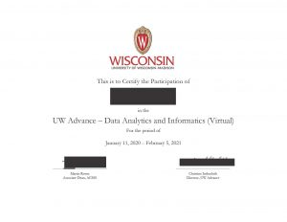

Sample Recommendation Letter

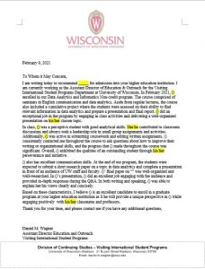

“There are so many activities after classes in this program that encouraged me to be more active and take initiative instead of being silent. This helped me to know more and learn more and also make more friends!”
—QINGJIE (JENNY) YOU, STUDENT FROM UW ADVANCE BIG DATA PROGRAM

